Fundamentals of AI – Assessment

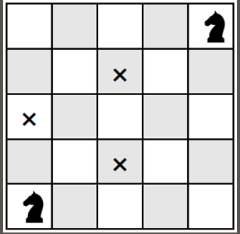

Chess Knight Problem

BFS Algorithm

Name: Talal Al-Ahbabi

Student ID: 303067072

Problem Description:
The problem used in this project is the chess knight move. The main idea is to make the knight move from the start position to the goal position in chessboard with least number of moves. The knight in chess is not the same as the other pieces in chess, because it moves in an (L) shape. In other words, it moves two steps in one direction and one step in another, which makes it hard to find the right path to reach the goal.

The user can choose the size of the board (5x5 or bigger), the user also can define the start position and the goal position, additionally it possible to create obstacles the knight can’t pass through. The idea of the project is to find the shortest path from the start to the goal while considering the size of the board and the obstacles.

This problem can be solved by using the Breadth-First Search algorithm (BFS) the reason behind that is this algorithm guarantees reaching the goal with least number of moves, especially that every move has the same cost (no different weights). The problem is used often as an example of how Artificial Intelligence works with pathfinding instead of using normal programming depends on simple choices.

Used Algorithm:
In this project Breadth-First Search algorithm (BFS) has been used to solve the problem of the knight shortest path to the goal. The reason for choosing BFS is that it searches for all the possible moves step by step and equally, so that discover all the coordinates that can be reached in one move, then it goes for the second coordinates that require two moves, and so on. So, the first time the algorithm reaches the goal, it would have the least number of moves, which is what is needed for the problem.

The algorithm depends on using a queue to save the coordinates need to be visited sequentially, also it uses a parent dictionary to save every coordinate where it comes from, so the path can be detected after reaching the goal. Every move from the knight is treated as an edge in unweighted graph, that’s what makes BFS the perfect algorithm to be used in this kind of problems.

The algorithm also considers the border size and the obstacles, so that check before every move if it is inside the board or if it was an obstacle.

Shortly, the BFS was chosen because it guarantees to reach the goal with shortest path, easy to apply, suitable for problems that depend on the number of moves rather than cost. This clarifies the reason it used in AI applications that related to searching and pathfinding.

Explanation of the code:
The code starts by asking for the inputs from the user, which are the board size (number of the rows and columns), then the coordinates of start point and goal point, additionally the choice of adding obstacles. After that the program starts by applying BFS algorithm to find the shortest path for the knight moves.

First, it checks that the start position and the goal position inside the board boundaries and not blocked. After that it uses the queue to save the coordinates that will be visited in sequence, also it saves with variable called parent to know the path of the knight from the start to the goal position.

In every repetition, a cell is extracted from the queue, then all possible moves for the knight get generated from that cell by using a special function, considering the boundaries of the board and the obstacles. If the algorithm reached the goal, the path gets detected by the parent to get the result.

After finding the path, the program prints the coordinates, number of moves, show the physical board, where the starting point showed as S, Goal as G, obstacles as X, the moves of the knight as numbers according to the order of movement.

Output:
After running the program, shows the result clearly to the user. Firstly, print the path of the knight from the starting position until the goal position as an organized coordinate. After that clarify the needed moves to reach the goal, which is the shortest path.

Additionally, to that, the program prints the full board on screen, and shows:
- Starting point wit letter S
- Target point with letter G
- Obstacles with letter X (if there is any)
- The moves of the knight as numbers according to the order of movement
This way the user can see the solution as a text and visually at the same time and make sure that the algorithm reached the goal with least number of moves.

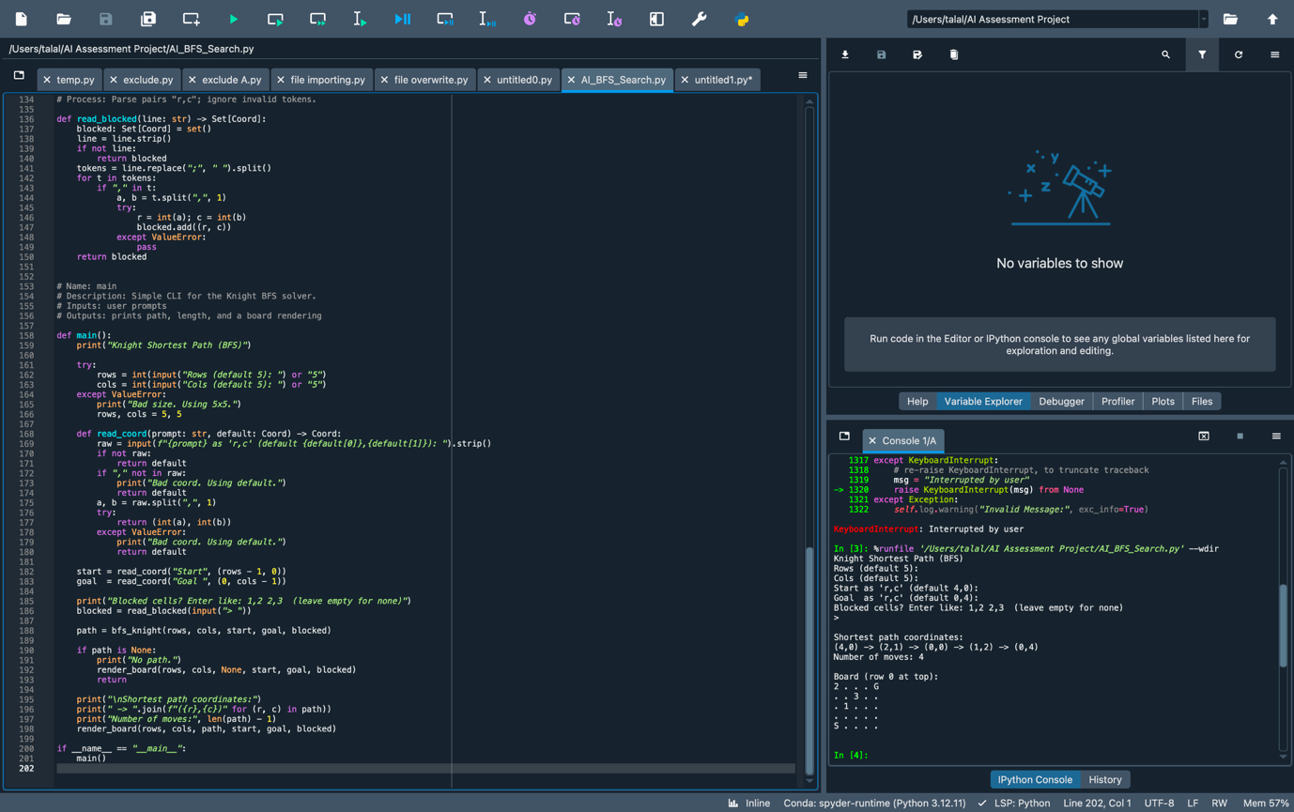

Code:
# I confirm that this assignment is my own work.

# This program solves the chess knight problem it uses Breadth-First Search algorithm.
# The idea of this program is to find the lowest number of moves that a knight can take
# to reach from the start to the goal position, also there is an optional blocked cell
# that represent obstacles on the board.

# The algorithm works to find the shortest path because BFS explores all the positions
# one by one, that means it reaches the goal using the minimum number of moves.
# The program represents the board as a 2D grid where each cell is defined by a coordinate (row, column).

# A knight can move in eight possible directions: two squares vertically and one horizontally,
# or two horizontally and one vertically. The complex of this program is O (V + E), where V is the number of
# cells and E are the possible moves between them. The program outputs the coordinates of
# The shortest path, the number of moves, and a printed grid showing the path from the
# Start to the goal. This approach a demonstrates how BFS can be applied on real life
# problems related to path finding in AI.

from collections import deque
from typing import List, Tuple, Set, Optional

Coord = Tuple[int, int]

# Name: in_bounds
# Description: Check if a coordinate is inside the board.
# Inputs: r (int), c (int), rows (int), cols (int)
# Outputs: bool
# Process: 0 <= r < rows and 0 <= c < cols

def in_bounds(r: int, c: int, rows: int, cols: int) -> bool:
return 0 <= r < rows and 0 <= c < cols

# Name: knight_neighbors
# Description: Generate all legal knight moves from a cell, skipping obstacles.
# Inputs: cell (Coord), rows (int), cols (int), blocked (Set[Coord])
# Outputs: List[Coord]
# Process: Try the 8 knight deltas; keep those in-bounds and not blocked.

def knight_neighbors(cell: Coord, rows: int, cols: int, blocked: Set[Coord]) -> List[Coord]:
r, c = cell
deltas = [
(-2, -1), (-2, +1),
(-1, -2), (-1, +2),
(+1, -2), (+1, +2),
(+2, -1), (+2, +1),
]
nbrs: List[Coord] = []
for dr, dc in deltas:
nr, nc = r + dr, c + dc
if in_bounds(nr, nc, rows, cols) and (nr, nc) not in blocked:
nbrs.append((nr, nc))
return nbrs

# Name: bfs_knight
# Description: BFS to find the shortest path for a knight from start to goal.
# Inputs: rows, cols, start (Coord), goal (Coord), blocked (Set[Coord])
# Outputs: path (List[Coord] or None)
# Process: Standard BFS with parent map to reconstruct the path.

def bfs_knight(rows: int, cols: int, start: Coord, goal: Coord, blocked: Set[Coord]) -> Optional[List[Coord]]:
if not in_bounds(*start, rows, cols) or not in_bounds(*goal, rows, cols):
return None
if start in blocked or goal in blocked:
return None
if start == goal:
return [start]

q = deque([start])
parent = {start: None}
seen = {start}

while q:
cur = q.popleft()
if cur == goal:

path: List[Coord] = []
at = goal
while at is not None:
path.append(at)
at = parent[at]
path.reverse()
return path

for nb in knight_neighbors(cur, rows, cols, blocked):
if nb not in seen:
seen.add(nb)
parent[nb] = cur
q.append(nb)

return None

# Name: render_board
# Description: Print the board with path, start, goal, and obstacles.
# Inputs: rows, cols, path (List[Coord] or None), start, goal, blocked
# Outputs: None (prints)
# Process: Marks:
# 'S' = start, 'G' = goal, 'X' = obstacle, numbers for step order.

def render_board(rows: int, cols: int, path: Optional[List[Coord]], start: Coord, goal: Coord, blocked: Set[Coord]) -> None:
grid = [["." for _ in range(cols)] for _ in range(rows)]

for (r, c) in blocked:
if in_bounds(r, c, rows, cols):
grid[r][c] = "X"

if path:
for idx, (r, c) in enumerate(path):
grid[r][c] = str(idx) if idx not in (0, len(path)-1) else grid[r][c]

sr, sc = start
gr, gc = goal
if in_bounds(sr, sc, rows, cols):
grid[sr][sc] = "S"
if in_bounds(gr, gc, rows, cols):
grid[gr][gc] = "G"

print("\nBoard (row 0 at top):")
for r in range(rows):
print(" ".join(grid[r]))
print()

# Name: read_blocked
# Description: Read blocked cells from user like: "1,2 2,3" (space-separated).
# Inputs: line (str)
# Outputs: Set[Coord]
# Process: Parse pairs "r,c"; ignore invalid tokens.

def read_blocked(line: str) -> Set[Coord]:
blocked: Set[Coord] = set()
line = line.strip()
if not line:
return blocked
tokens = line.replace(";", " ").split()
for t in tokens:
if "," in t:
a, b = t.split(",", 1)
try:
r = int(a); c = int(b)
blocked.add((r, c))
except ValueError:
pass
return blocked

# Name: main
# Description: Simple CLI for the Knight BFS solver.
# Inputs: user prompts
# Outputs: prints path, length, and a board rendering

def main():
print("Knight Shortest Path (BFS)")

try:
rows = int(input("Rows (default 5): ") or "5")
cols = int(input("Cols (default 5): ") or "5")
except ValueError:
print("Bad size. Using 5x5.")
rows, cols = 5, 5

def read_coord(prompt: str, default: Coord) -> Coord:
raw = input(f"{prompt} as 'r,c' (default {default[0]},{default[1]}): ").strip()
if not raw:
return default
if "," not in raw:
print("Bad coord. Using default.")
return default
a, b = raw.split(",", 1)
try:
return (int(a), int(b))
except ValueError:
print("Bad coord. Using default.")
return default

start = read_coord("Start", (rows - 1, 0))
goal = read_coord("Goal ", (0, cols - 1))

print("Blocked cells? Enter like: 1,2 2,3 (leave empty for none)")
blocked = read_blocked(input("> "))

path = bfs_knight(rows, cols, start, goal, blocked)

if path is None:
print("No path.")
render_board(rows, cols, None, start, goal, blocked)
return

print("\nShortest path coordinates:")
print(" -> ".join(f"({r},{c})" for (r, c) in path))
print("Number of moves:", len(path) - 1)
render_board(rows, cols, path, start, goal, blocked)

if __name__ == "__main__":
main()

